Problem Statement:
Employee promotion is an essential component of company success and employee satisfaction. Now-a-days Employee’s promotion is not carried out effectively due to complexity in the promotion procedure and also there is a lack of transparency processes makes it difficult to accurately predict which employees are most likely to succeed in higher-level-roles.
Abstract:
Employee promotion is a critical component of business performance, necessitating careful decision-making to find qualified candidates. This study proposes a machine learning-based approach to employee promotion prediction that makes use of a diversified dataset that includes significant factors such as performance measures, tenure, training participation, and previous promotions.
The suggested prediction model makes use of cutting-edge machine learning methods, with a particular emphasis on the Decision Tree approach due to its interpretability and effectiveness in dealing with both numerical and categorical data. Pandas and NumPy are used to preprocess the dataset, ensuring data purity and feature engineering for best model performance.
Algorithm : Decision Tree
A decision tree structure is used to construct classification or regression problems. While developing a classification tree, the dataset will be broken down into smaller sections. As a result, a tree is formed with leaf nodes and a decision node. A leaf node implies a categorization or decision, while a decision node usually has two or more branches. The root node in a tree refers to the best predictor and is at the top decision node. In decision tree modelling, both quantitative and qualitative data can be used

Data Sets: The dataset is from Kaggle 2020 and describes large multi-nation companies (MNCs)
Training Set
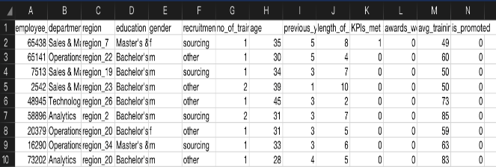
Testing Set
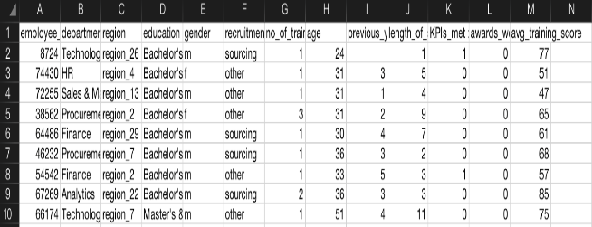
Data visualization
Graphical representation has been done with each parameter to see in details how each parameter affects the possibility of employees getting promotion
1)Employees from Procurement & Technology department are mostly likely are getting promoted
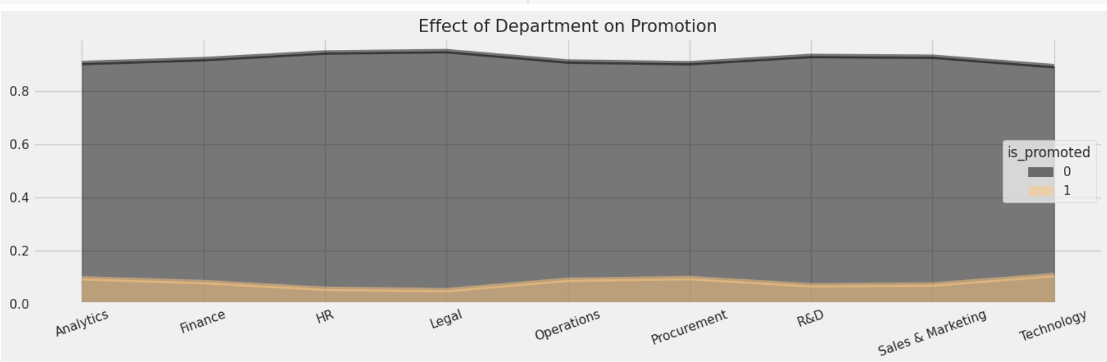

2)Employees with 'Very good' rating (5) are most likely to be promoted.
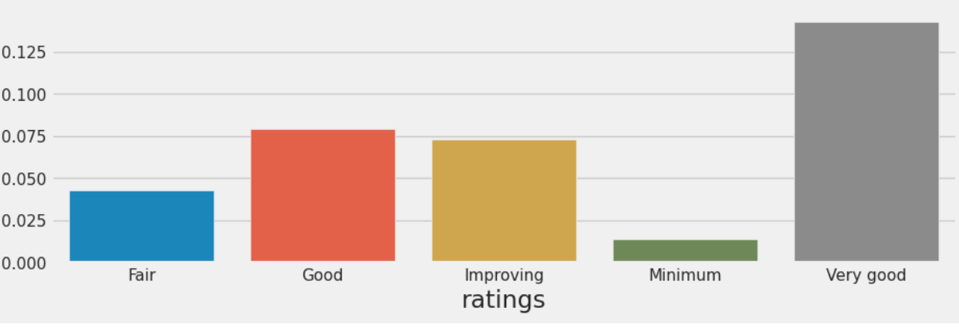

An employee aged between 25 and 40 years is likely to be promoted
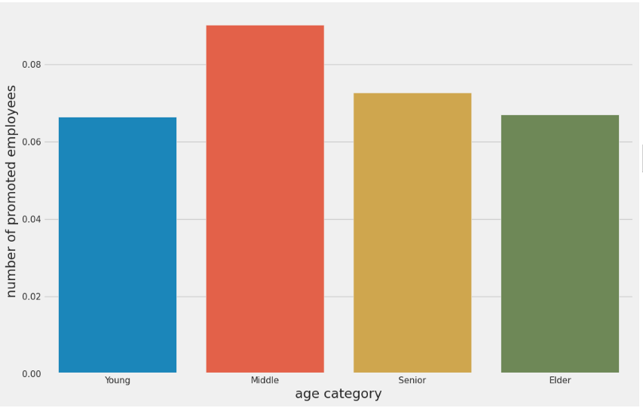

4)Employees from Technology and Procurement Department who won awards are mostly likely are getting promoted.
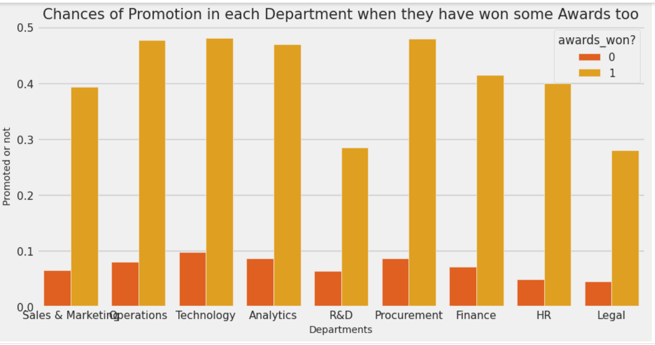

Employees who done their bachelors are most likely are getting promoted in maximum number
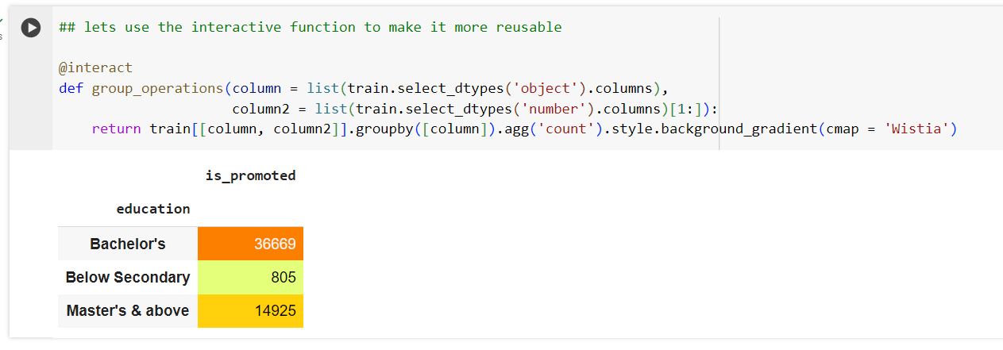
Males have high probability of getting promoted in Maximum number
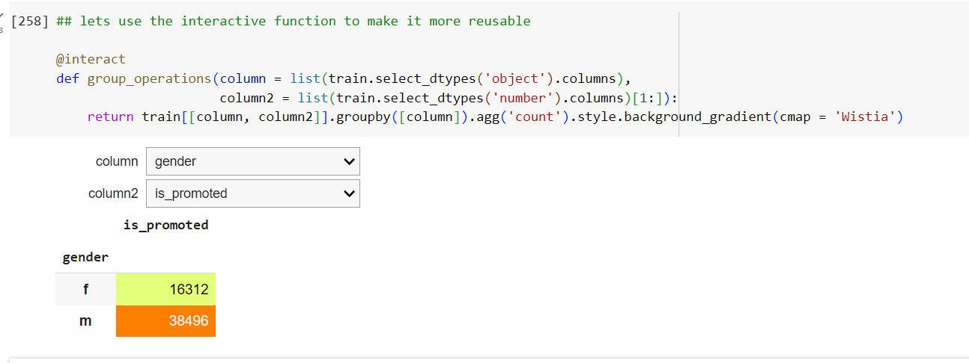

Results:
The below output indicates that Employee get chance of getting promoted
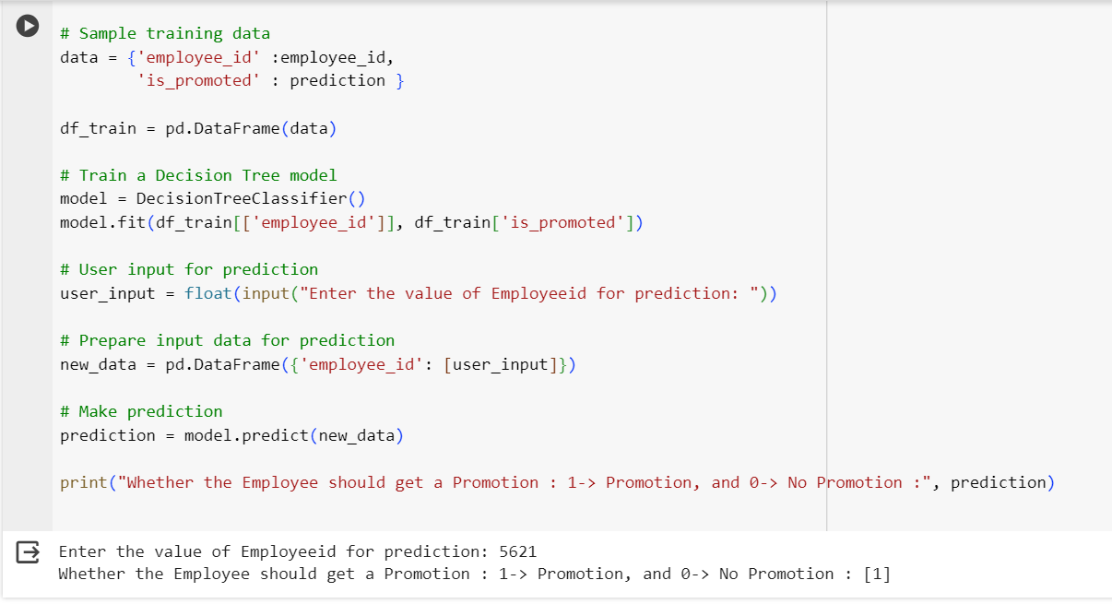

The below output indicates that Employee get chance of getting not promoted
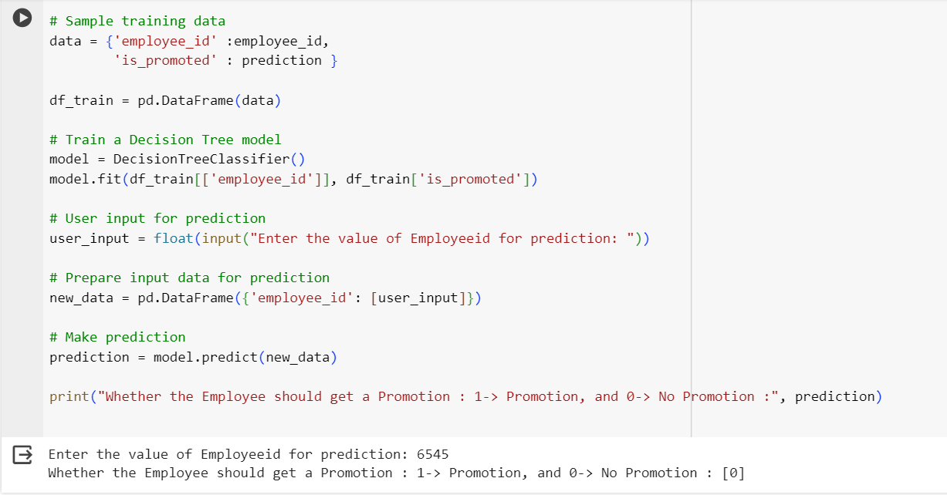

Conclusion
The goal of this project was to create a supervised machine learning classification model for promotion determination. information was utilized to forecast which employees were eligible for promotion. Knowing which staff are qualified for advancement is critical for any firm. Furthermore, the larger the organization, the more time and work it takes to manually identify people qualified for advancement. As a result, developing a model that identifies prospects for potential advancement is quite beneficial. The following prediction models was created is ‘The Decision Tree’. The findings show that there was no bias and that the features of the recruitment channel and department did not play important roles in promotion. The algorithms were able to perform well despite the relatively minimal data. More data would result in better-optimized solutions. Thus, machine learning model can reduce the amount of time spent on decision making, enhancing productivity.

